**Steps to set the path of jdk**

**Step 1**: Open the command prompt by searching cmd on search bar in home page and type **javac** and press enter. You will find the message i.e. **javac is not recognised as an internal or external command**. Therefore it is required to set the path.

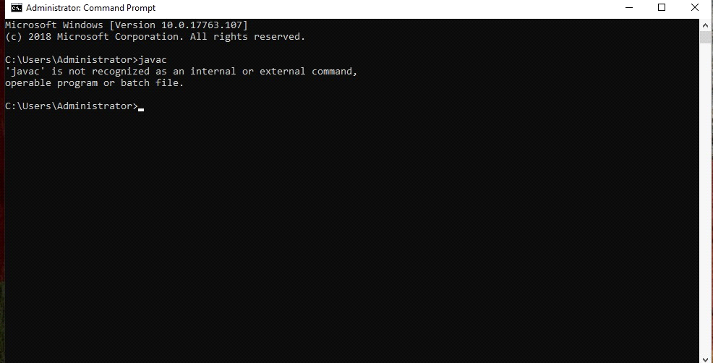

**Step 2** : Click on **this pc** and go to the drive where you installed java in your computer.

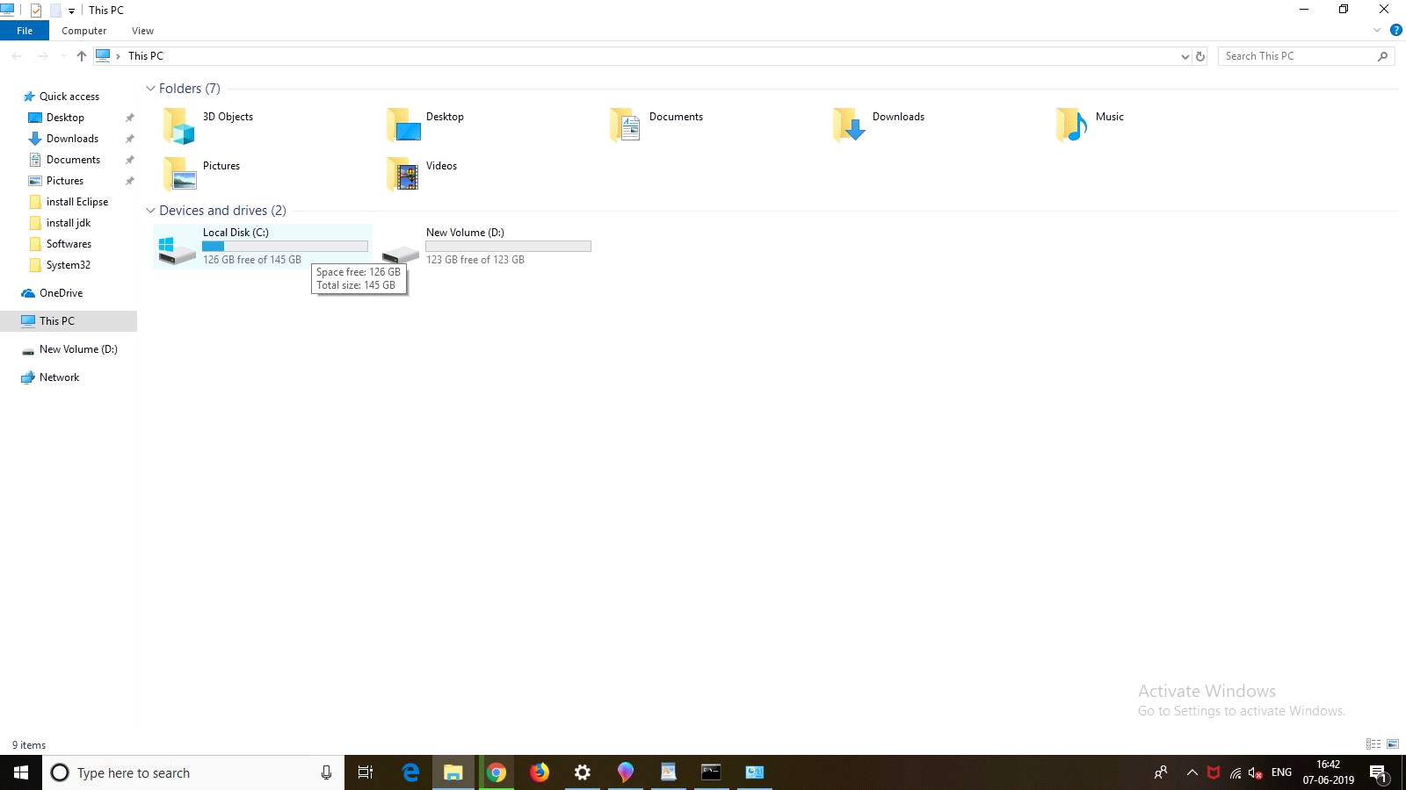

**Step 3**: Double click on the **program files** and then go to the **Java** folder.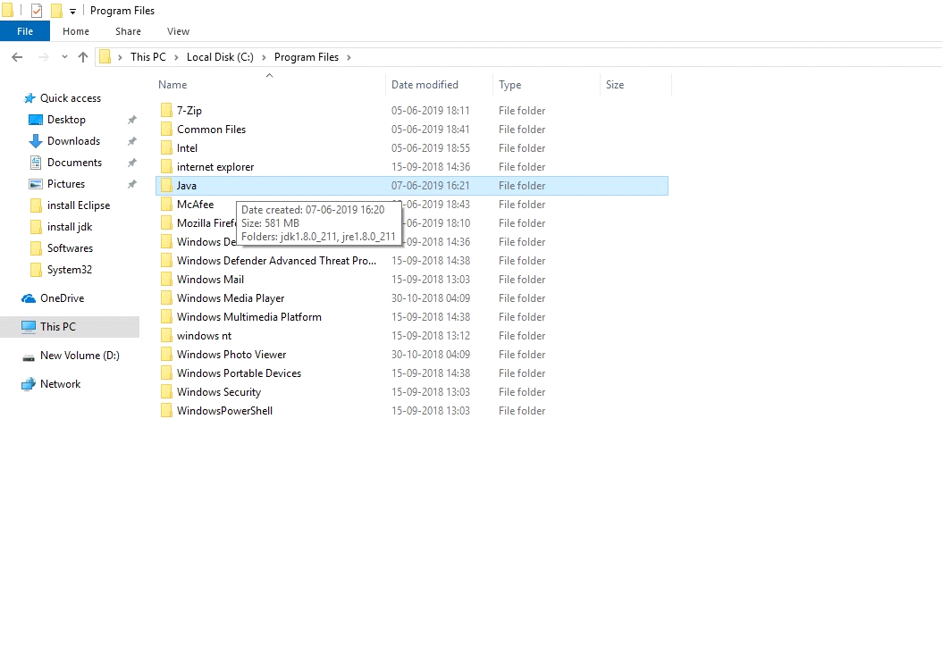

**Step 4** : Double click on **jdk1.8.0_211**

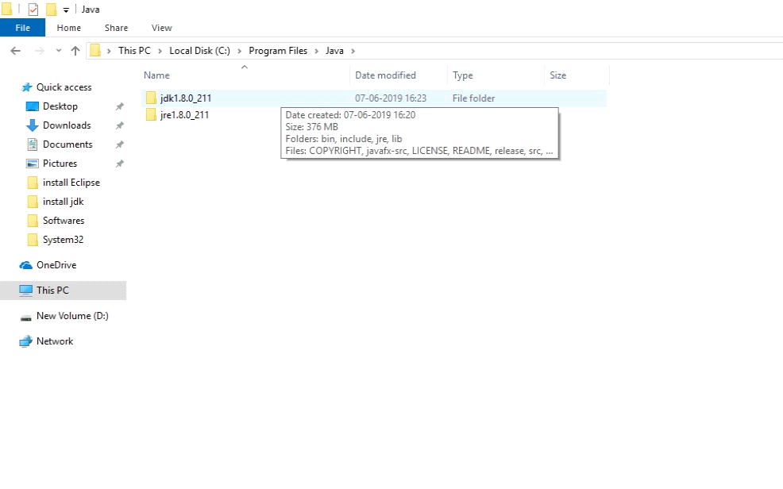

**Step 5** : Double click on **bin** folder.

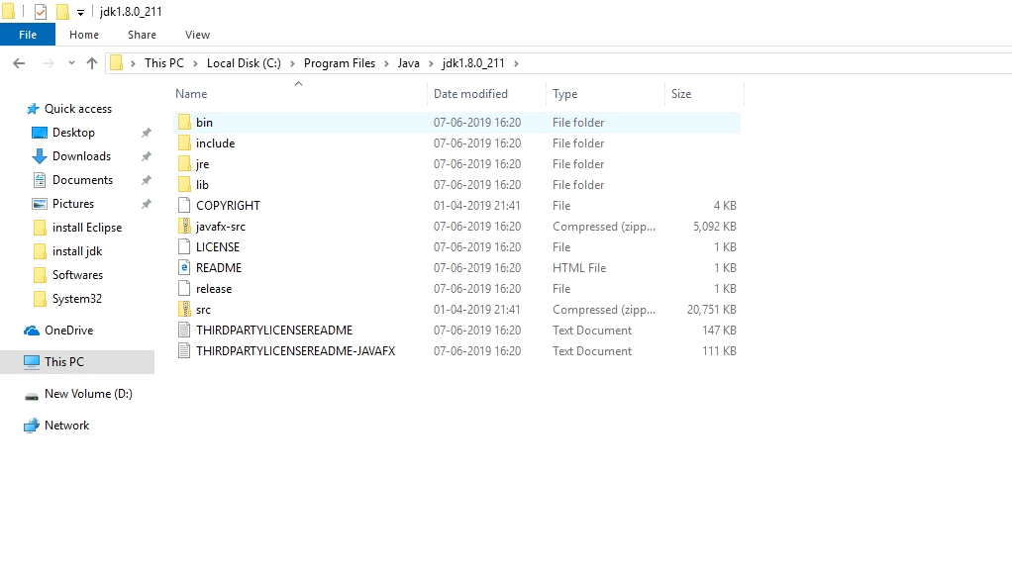

**Step 6** : Copy the complete path.

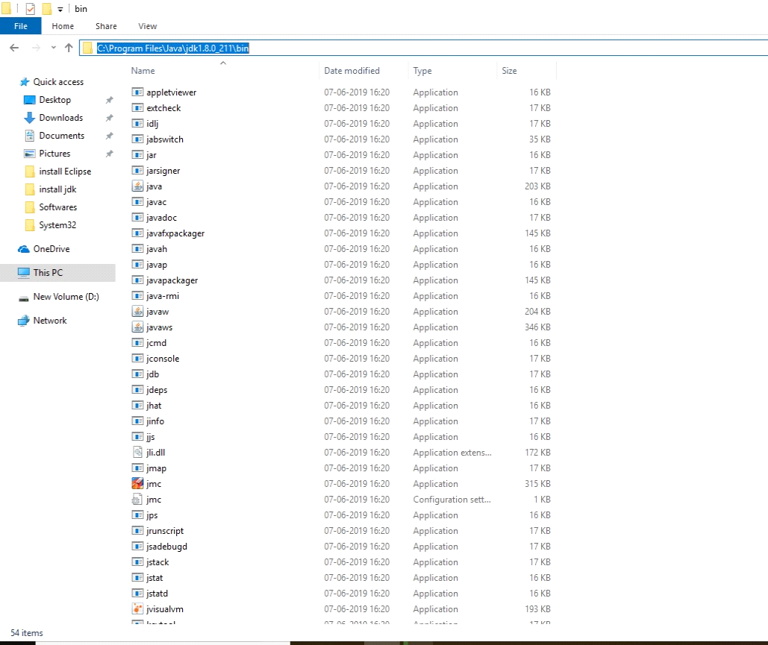

**Step 7** : Go to the **This pc** and right click on it and go to the **properties**.

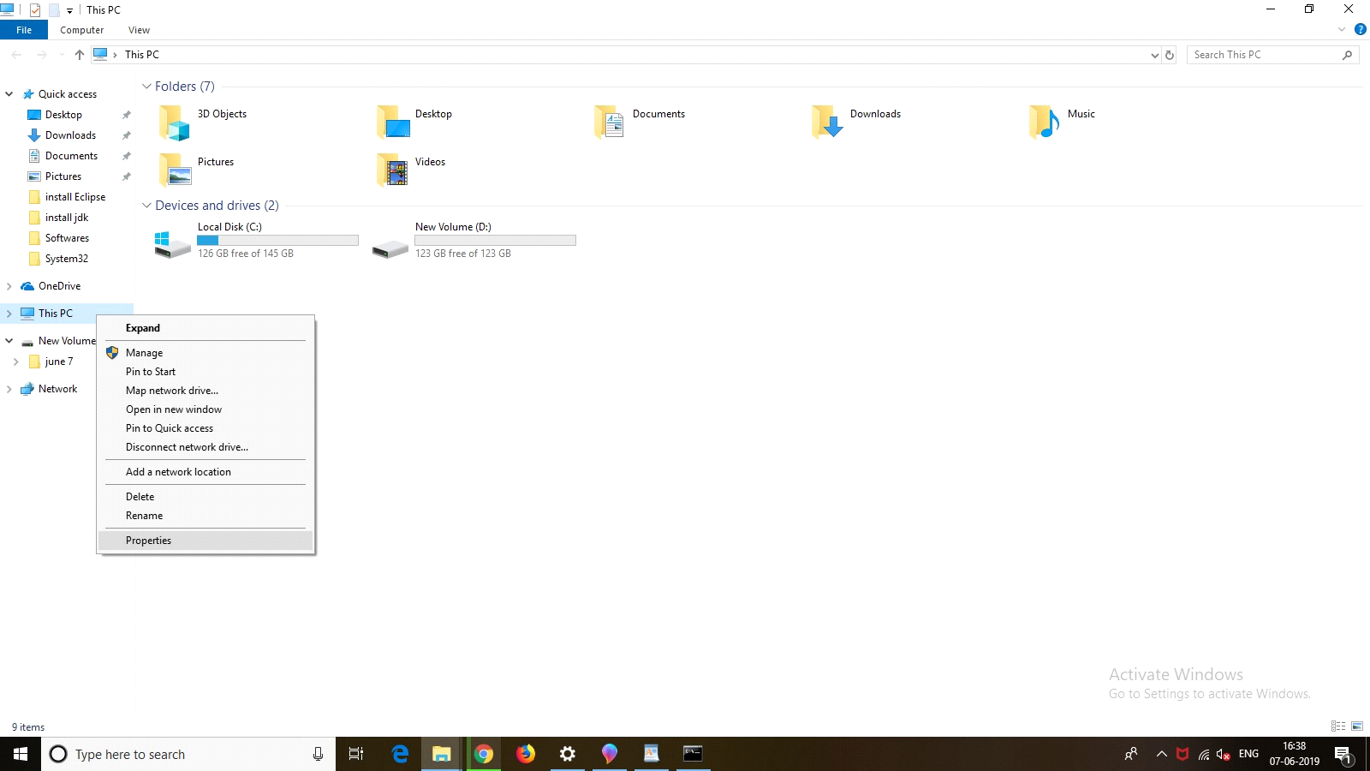

Now click on **Advanced System Settings.**

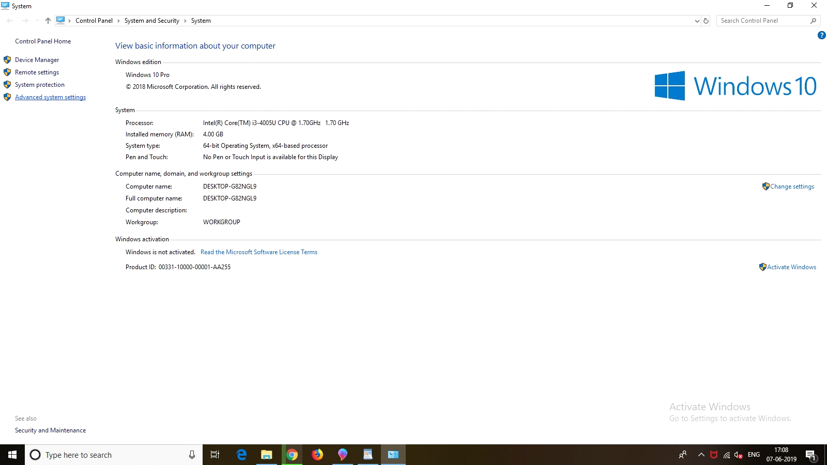

**Step 8** : Go to the **Enviornment Variables**.

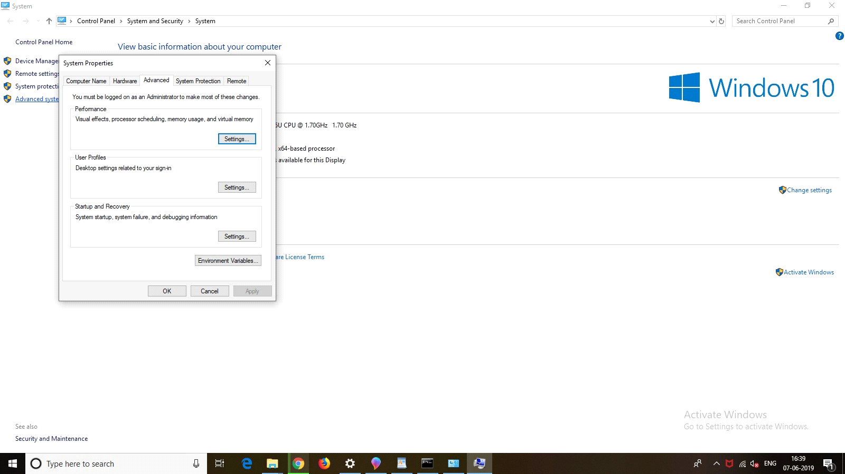

**Step 9** : Double click on the **path**.   
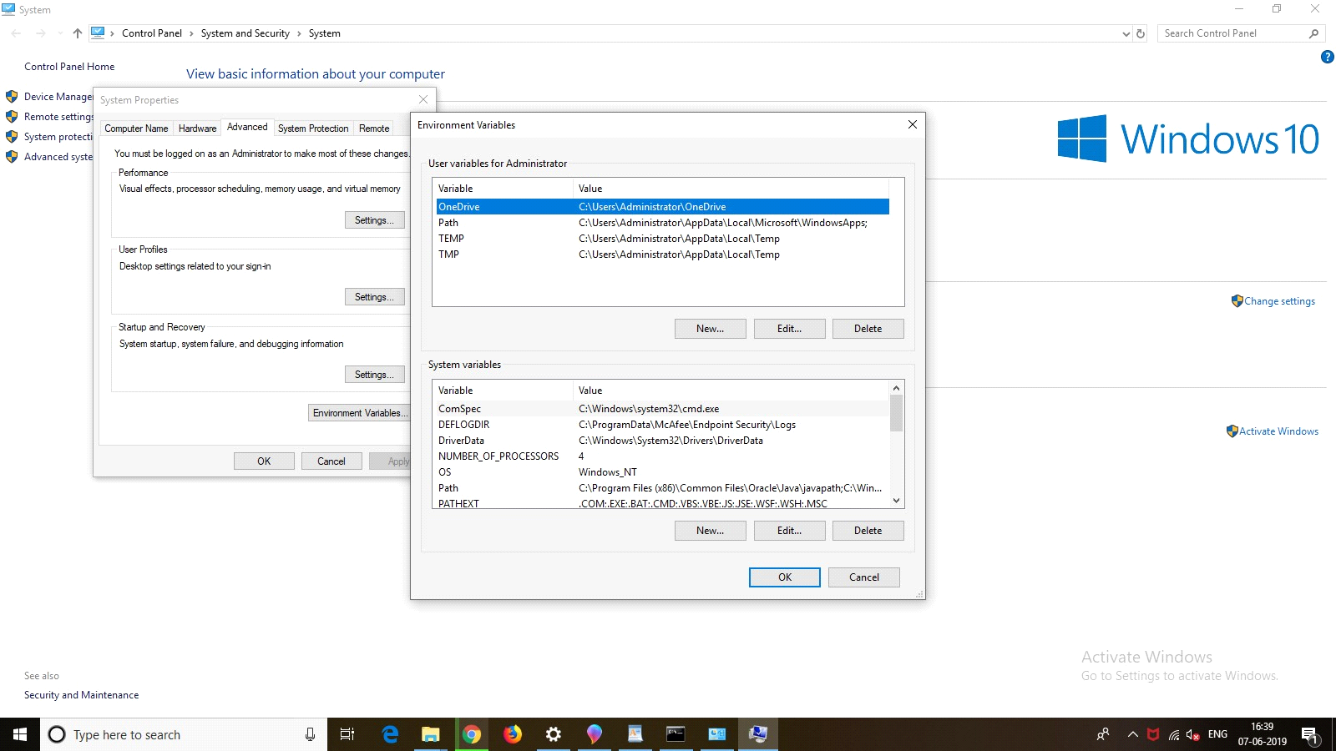

**Step 10** :Click on the **New** button and paste the path that you have coppied before. Now press the **OK** button.

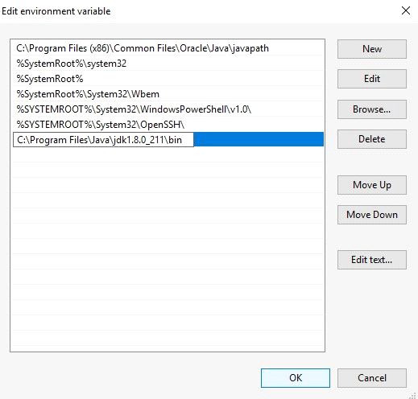

**Step 11** : Click on the **OK** Button.

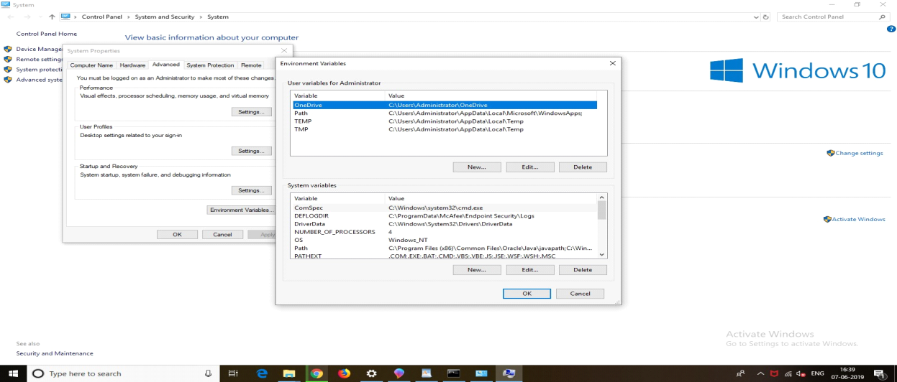

**Step 12** : Click on the **OK** button.



**Step 13** : Again open the command prompt and type **javac** and press **enter**.

